Goto this link

https://github.com/suresh2rck/cucumberNaturalPlugin.git

step 1:

step 2:

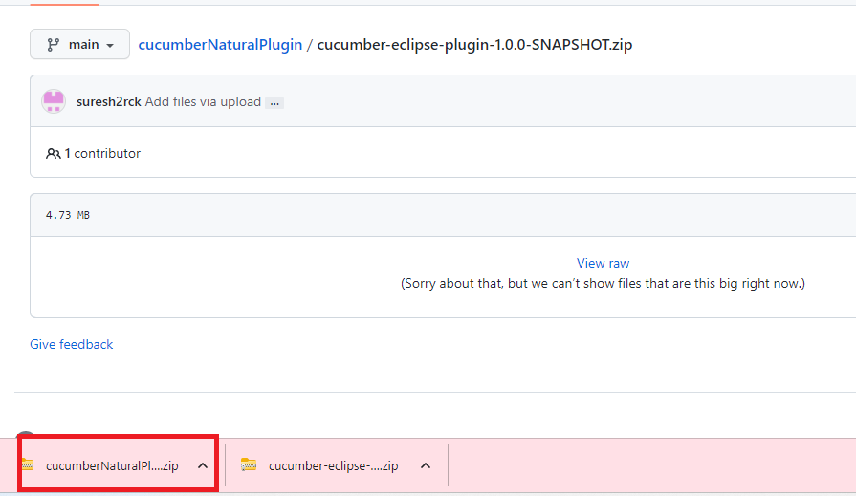

step 3:

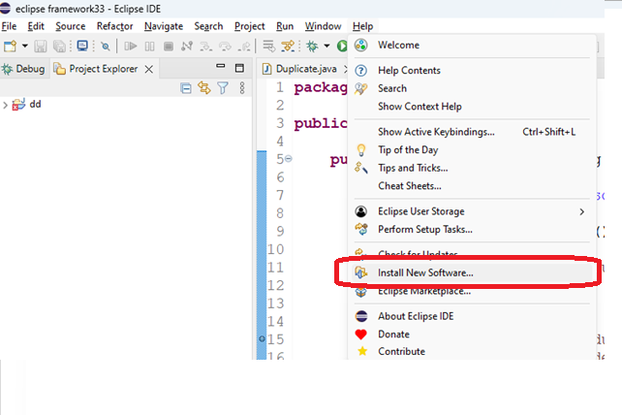

step 4: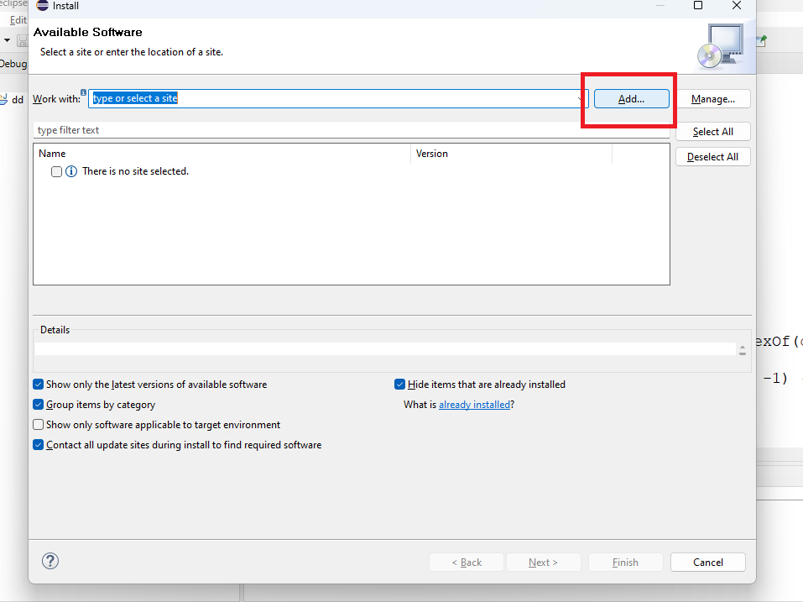

step 5:

install new software -> add ->> Name= Natural and location click on Archive and upload the file "cucumber-eclipse-plugin-1.0.0-SNAPSHOT"

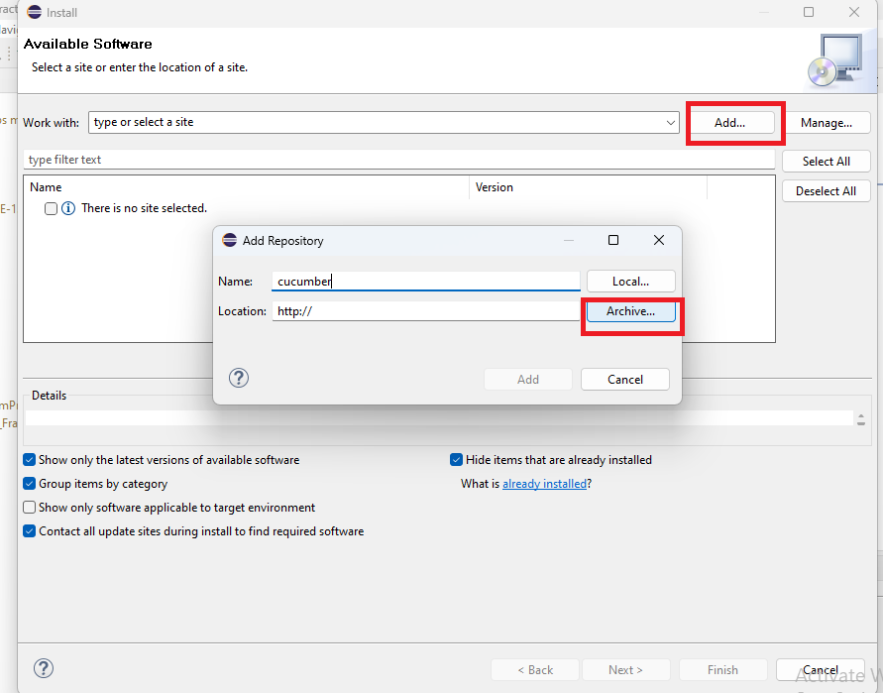

Step 6:

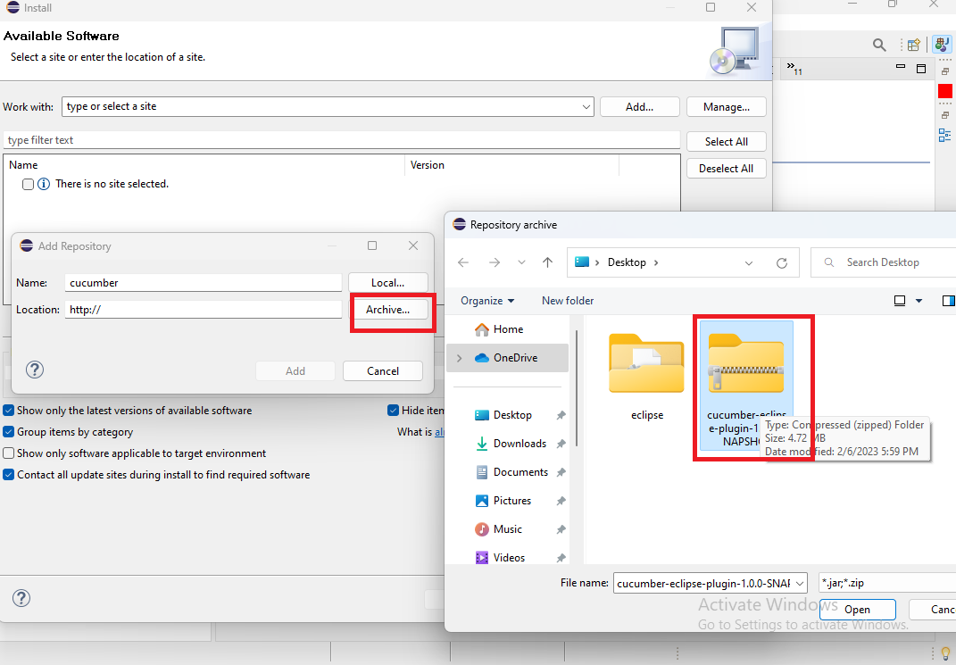

Step 7:

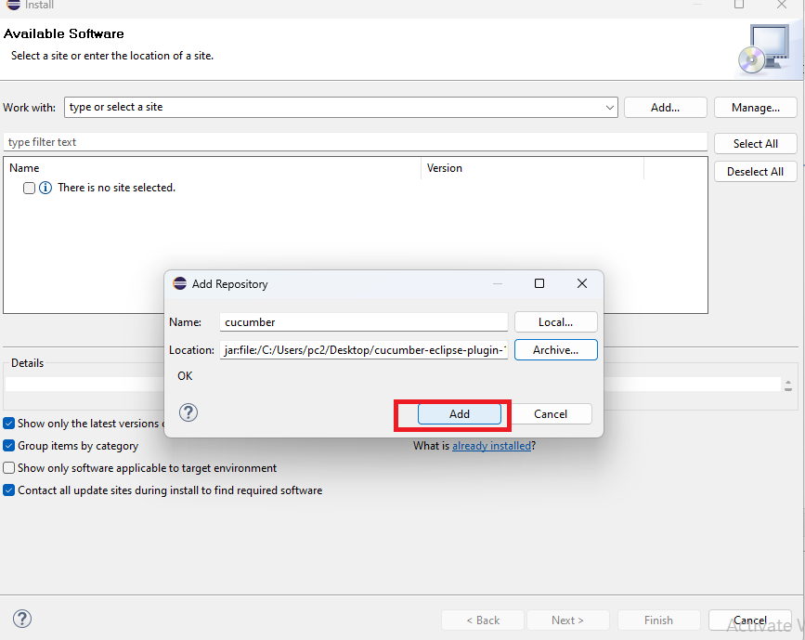

Step 8:

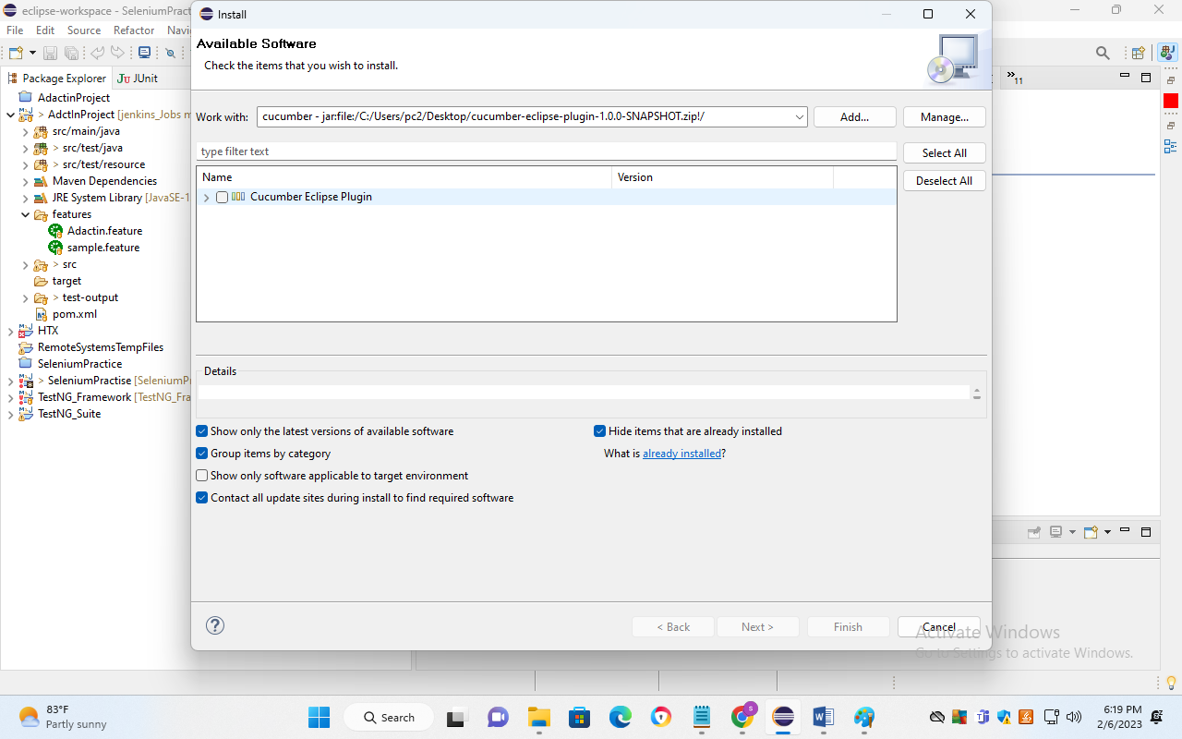

Plugin installed succesfully…….

Step 9:

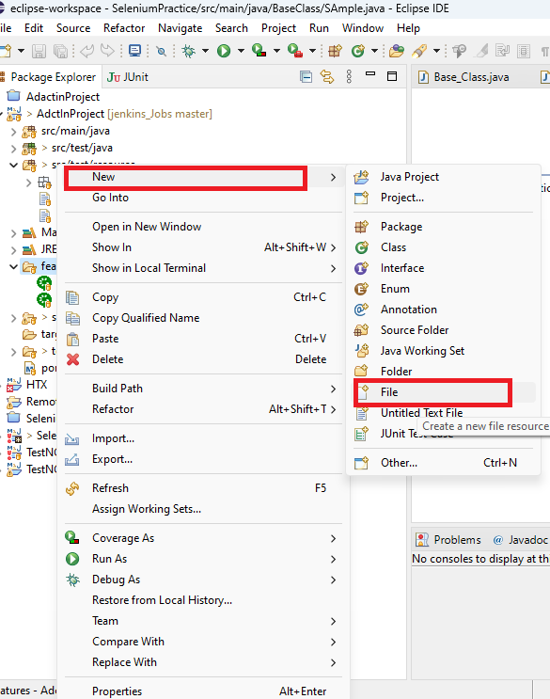

Step 10: create file -🡪 smoke.feature

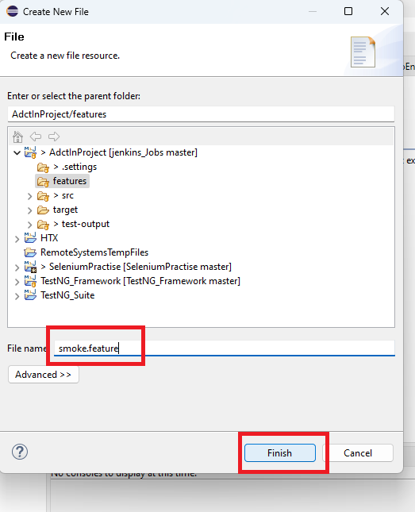

Step 11:

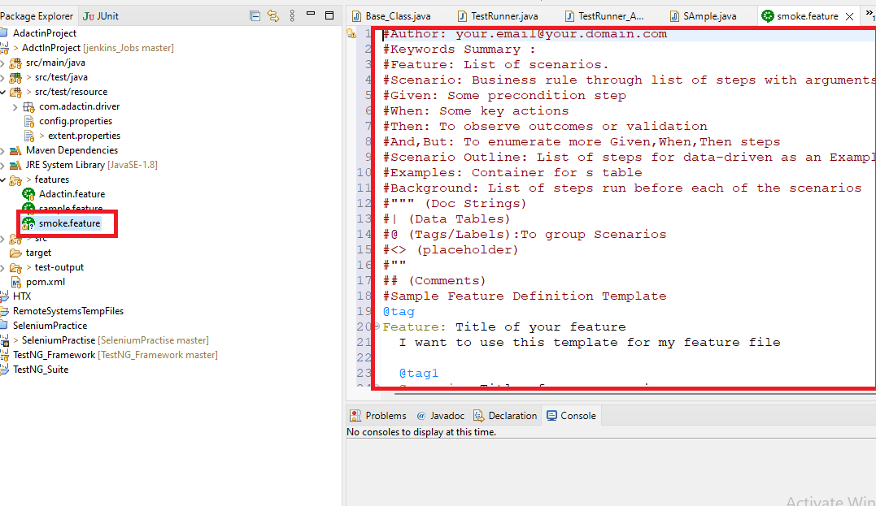

Congratulations If u got this then cucumber has been installed successfully…..!!!!!!